

HOL-LAMP on Azure

Abdul Rasheed Feroz Khan

Technical Evangelist

fb.com/abdulrasheed92

© 2015 Microsoft Corporation. All rights reserved.

Table of Contents

Linux Workloads, deploying LAMP stack on azure 3

Introduction 3

Deploying LAMP stack 3

Creating Linux VM using Azure Portal 3

Lab objectives 3

Understand Azure Portal. 3

Create Storage Account. 3

Create Virtual Network. 5

Create Virtual Machine. 6

Installing Apache, MySQL and PHP with a Sample Application 9

Lab objectives 9

Connect to VM. 9

Install Apache, MySQL and PHP. 9

Deploy Sample App in Apache. 9

Restore MySQL DB. 10

# Linux Workloads, deploying LAMP stack on azure

## Introduction

One out of 5 Virtual Machines on Azure are now running Linux. Azure supports several flavors of Linux, such as CentOS, SUSE, openSUSE and Ubuntu. After creating Virtual Machine you can deploy any type of software like Apache for front end, MySQL for database etc.. While creating Linux Virtual Machine, by default azure opens end point for SSH port. If you want to access PHP application, you have to open port 80 while creating Virtual Machine.

# Deploying LAMP stack

This section contain steps to deploy LAMP stack on Azure Virtual Machine. First step explains how to create Ubuntu Virtual Machine from Azure portal, we define host name, storage account, virtual network, subnet and public DNS name. Second step explains how to install Apache, MySQL, and PHP on Ubuntu machine.

## Creating Linux VM using Azure Portal

This lab will take you thru tasks to perform to create a Linux Based VM (Ubuntu in this case) using Microsoft Azure Portal.

### Lab objectives

1. Understand Azure Portal.
2. Create Storage Account.
3. Create Virtual Network.
4. Create Virtual Machine.

Sequence on Tasks

### Understand Azure Portal.

1. Open Windows Azure portal from below link using your preferred browser https://manage.windowsazure.com

b. Login to Microsoft Azure portal using your credentials.

### Create Storage Account.

Virtual Machine VHD files are stored in Azure Blob Storage of your storage account. There are four types of replication modes are available for storage account.

**Locally redundant storage (LRS).** Locally redundant storage maintains three copies of your data. LRS is replicated three times within a single facility in a single region.

**Zone-redundant storage (ZRS)**. Zone-redundant storage maintains three copies of your data. ZRS is replicated three times across two to three facilities, either within a single region or across two regions, providing higher durability than LRS.

**Geo-redundant storage (GRS).** Geo-redundant storage is enabled for your storage account by default when you create it. GRS maintains six copies of your data. With GRS, your data is replicated three times within the primary region, and is also replicated three times in a secondary region hundreds of miles away from the primary region, providing the highest level of durability.

**Read access geo-redundant storage (RA-GRS).** Read access geo-redundant storage replicates your data to a secondary geographic location, and also provides read access to your data in the secondary location.

1. Click on **NEW** button.

01

1. Select **DATA SERVICES.**

02

1. Select **STORAGE**.

03

1. Select **QUICK CREATE**.

04

1. Enter storage account name in **URL** textbox. Select storage account **Location** and **Replication** type.

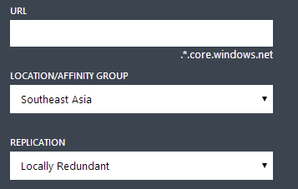

1. Click on **CREATE STORAGE ACCOUNT** to create storage account.

### Create Virtual Network.

Virtual Network isolates your Azure resources. You can define subnets inside your virtual networks. You can create subnets based on your application tiers like frontend, backend etc.

1. Click on **NEW** button.

01

1. Select **Network Services.**

06

1. Select **Virtual Network.**

07

1. Select **Custom Create.**

08

1. Enter **Virtual Network** Name and select **Virtual Network Location.**
2. Specify **DNS Servers** if any.
3. Specify **Virtual Network Address Spaces**. Here you can specify IP address ranges for subnets in CIDR blocks.

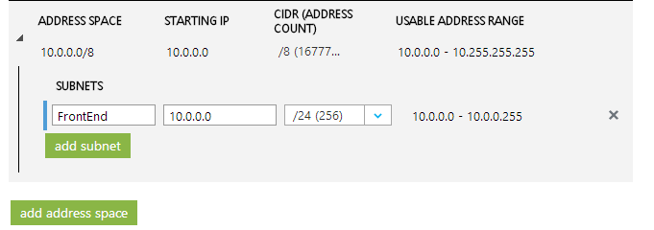

### Create Virtual Machine.

Virtual Machines are created under Cloud Services. Cloud Services are acts as NAT (Network Address Translation) instances, which forward traffic to Virtual Machines.

1. Click on **NEW** button.

C:\Users\sekhar.MACTORES\AppData\Local\Microsoft\Windows\INetCache\Content.Word\01.png

1. Select **Compute** section.

10

1. Select **Virtual Machine** section.

11

1. Select **From Gallery** section.

12

1. In **Choose an Image** popup select **Ubuntu** from left section, this displays available Ubuntu images list.
2. Select **Ubuntu Server 12.04 LTS** from image list.
3. Click Next button.
4. In **Virtual Machine Configuration,** provide **Virtual Machine Name, Size**, **New** **User Name and Password.** After this configuration Click Next button**.**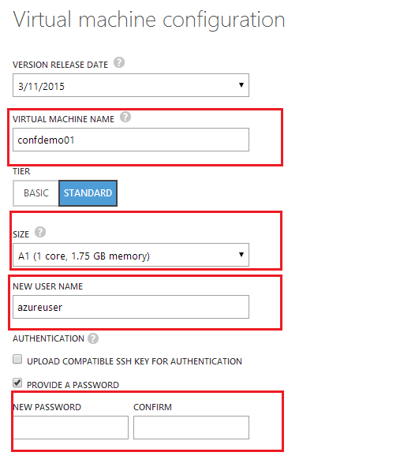
5. Select Create a new Cloud Service option on **Cloud Service** drop down list**.** Specify **Cloud Service DNS Name , Virtual Network, Subnet** and **Storage Account.** We are going to create only one Virtual Machine, so there is no need of **Availability Set**. To provide redundancy to your application, we recommend that you group two or more virtual machines in an Availability Set. This configuration ensures that during either a planned or unplanned maintenance event, at least one virtual machine will be available and meet the 99.95% Azure SLA. Create **Endpoint** for port 80 for PHP Web Site. After this configuration Click Next button**.**

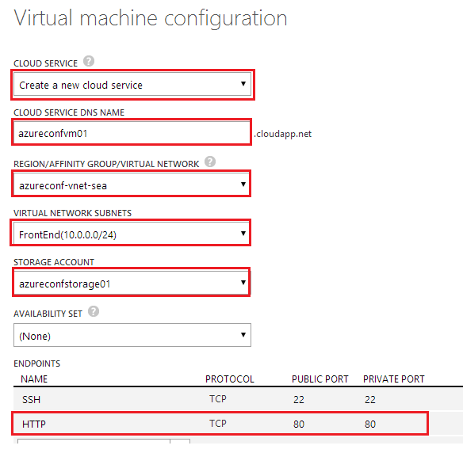

1. Virtual machine extensions make it easier to manage the virtual machine's configuration.
2. Click on Complete button to create Virtual Machine.

## Installing Apache, MySQL and PHP with a Sample Application

This lab will help you connect to Azure VM, install Apache, MySQL and PHP. Then deploy a sample app in Apache and Restore DB in MySQL.

### Lab objectives

1. Connect to VM.
2. Install Apache, MySQL and PHP.
3. Deploy Sample App in Apache.
4. Restore MySQL DB.

Sequence of Tasks:

### Connect to VM.

1. Connect to Azure machine from putty (already installed on your machine), copy public DNS name from azure portal and use username and password to login.

### Install Apache, MySQL and PHP.

1. After login to machine update local list of packages.

sudo apt-get update

1. Install apache.

sudo apt-get install apache2

1. Install MySQL. Below command prompts for MySql root user’s password. Specify password “P@ssw0rd123$” and hit enter.

sudo apt-get install mysql-server

1. Install PHP.

sudo apt-get install php5 php5-mysql

1. Restart apache service.

sudo service apache2 restart

### Deploy Sample App in Apache.

1. Download sample PHP application from Azure blob storage.

wget <http://goo.gl/JeAnbQ>-O InventoryApp.tar.gz

1. Extract files from tar.

tar -xzvf InventoryApp.tar.gz

1. Copy application files to /var/www/ folder.

sudo cp -R InventoryApp/* /var/www/

### Restore MySQL DB.

1. Download sample database from Azure blob storage.

wget <http://goo.gl/fUYSEP>-O InventoryDB.sql

1. Restore sample database.

mysql -u root -pP@ssw0rd123$ < InventoryDB.sql

1. Browse the application from below URL, use admin as username and password.

[http://[CloudServiceName].cloudapp.net/index.php](http://[cloudservicename].cloudapp.net/index.php)

# Tell us what you think

Help us shape future events by sharing your valuable feedback.

## Option 1

**Scan the QR code** to evaluate evaluate this session on your mobile device.



## Option 2

You can fill out evaluation of this session **directly** **through the App**

